CASHe App sentiment report

# Overall Summary

* App name: CASHe
* Number of reviews analyzed is 8,729
* Total number of reviews after cleaning the data is 5,382
* Timeline of reviews: 21 September,2020 to 21 January,2021 (122 days)

## Comparison of Aspects depending on how many numbers of people are writing about the aspect.

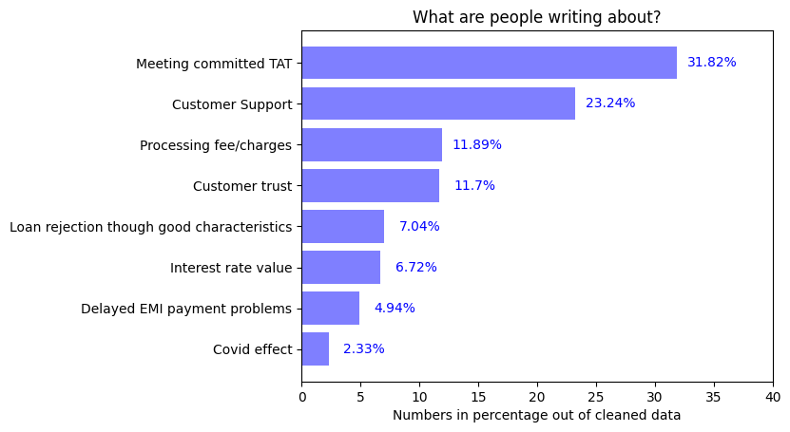

## Comparison of Aspects depending upon average rating given by users:

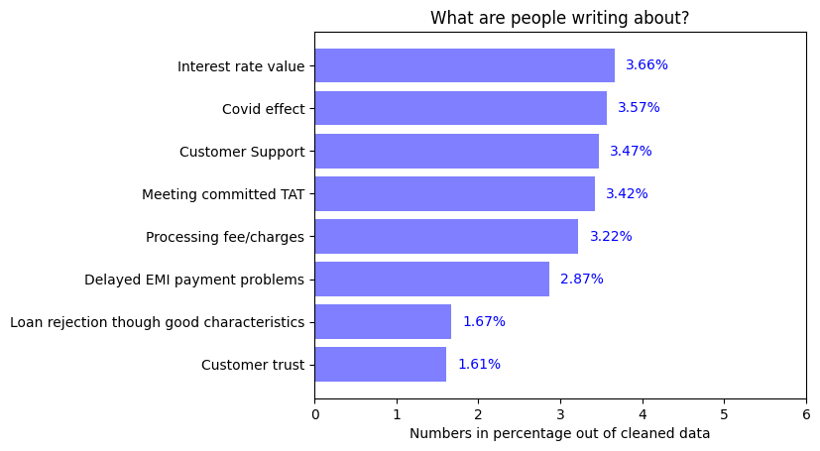

### Inference:

1. Large number of people are writing about meeting committed TAT and Customer support so these are important points from users’ perspective

# 1.Appropriate Interest rate

* Percentage of people writing about this topic is 6.72%



* Average rating given by users for this aspect is 3.66 out of 5
* 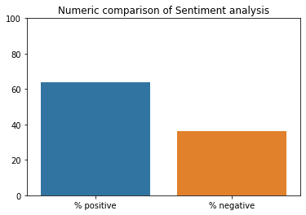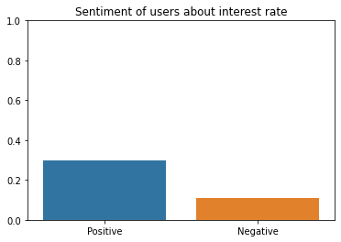Sentiment Analysis:

Figure 2: This shows how many people are positive or negative about this aspect

Figure 1: This shows Intensity of negativity or positivity of sentiments

### Inference:

1. People are more positive than negative about interest rate
2. Large number of people are Positive about interest rate and it matches the industry standards

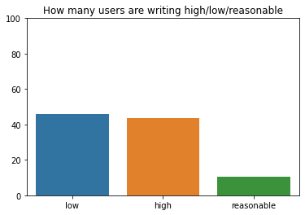Further Insights:

People saying interest rate is low =46.05%

People saying interest rate is high=43.42%

People saying interest rate is reasonable=10.52%

# 2.Delayed payments of EMI

* Percentage of people writing about this topic is 4.94%



* Average rating given by users is 2.87 out of 5
* 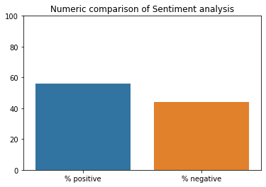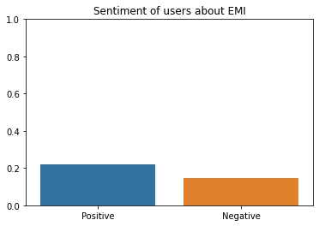Sentiment Analysis:

Figure 2: This shows how many people are positive or negative about this aspect

Figure 1: This shows Intensity of negativity or positivity of sentiments

### Inference

1. The sentiment of users is equally positive and negative
2. While the rating has slightly increased in the last four months

# 3. Loan rejection though good characteristics

* Percentage of people writing about this topic is 7.04%

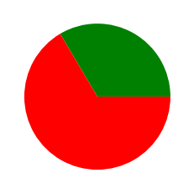

* Average rating given by users is 1.67 out of 5
* Sentiment analysis:

Figure 2: This shows how many people are positive or negative about this aspect

Figure 1: This shows Intensity of negativity or positivity of sentiments

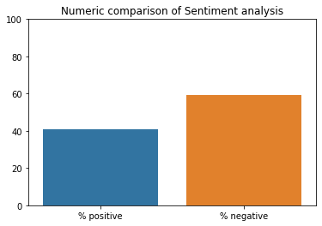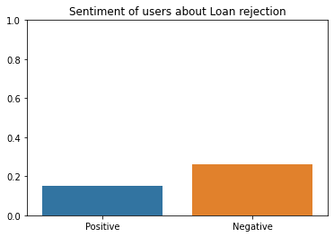

### Inference:

1. The sentiment of users about this aspect is negative

# 4. Customer queries / grievances support services:

* Percentage of users writing about this topic is 23.24%



* Average rating for Customer support is 3.47 out of 5
* 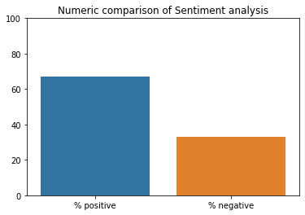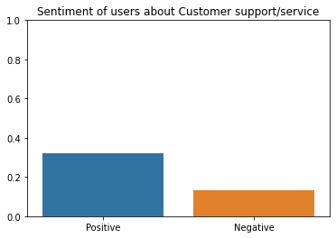Sentiment Analysis:

Figure 2: This shows how many people are positive or negative about this aspect

Figure 1: This shows Intensity of negativity or positivity of sentiments

### Inference:

1. Users are more positive about Customer support
2. Almost 25% of users are writing about this aspect

# 5.Processing Fee/ Extra Charges:

* Percentage of People writing about this topic is 11.89%



* Average rating for this topic is 3.22 out of 5
* 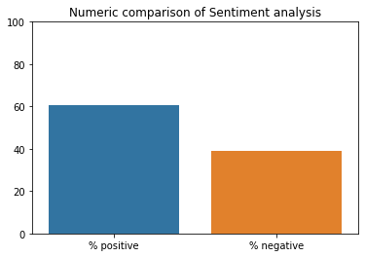 Sentiment:

Figure 2: This shows how many people are positive or negative about this aspect

Figure 1: This shows Intensity of negativity or positivity of sentiments

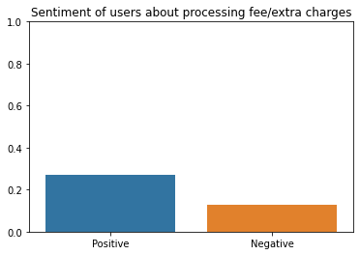

### Inference:

1. Users’ sentiment is overall positive

# 6. Loan disbursal to customer meeting the committed TAT

* Percentage of users writing about this topic is 31.82%



* Average rating by users is 3.42 out of 5
* 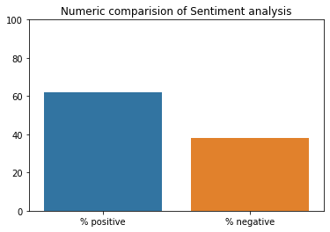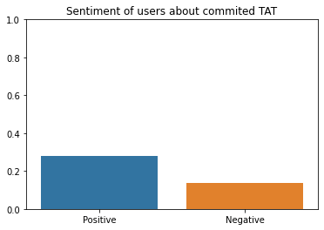Sentiment:

Figure 2: This shows how many people are positive or negative about this aspect

Figure 1: This shows Intensity of negativity or positivity of sentiments

### Inference:

1. Sentiment of users about TAT is mostly positive
2. Large number of users are writing about this topic and the cumulative sentiment is negative

# 7.Trust / legal/ fraud issues with app

* Percentage of users writing about this topic is 11.7%

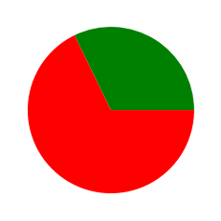

* Average rating by these users is 1.61 out of 5
* 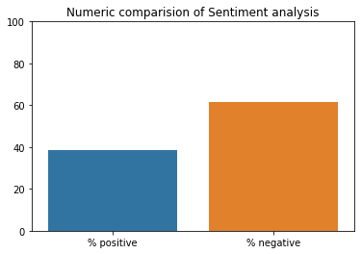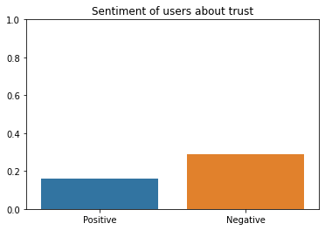Sentiment:

Figure 2: This shows how many people are positive or negative about this aspect

Figure 1: This shows Intensity of negativity or positivity of sentiments

### Inference:

### About 10% of users have written about trust on the app

### Out of which 60% users have suspicious view about the app while others are satisfied of its services

# 8.Covid-19 effect

* Percentage of users writing about this topic is 2.33%



* Average rating by these users = 3.57 of 5
* 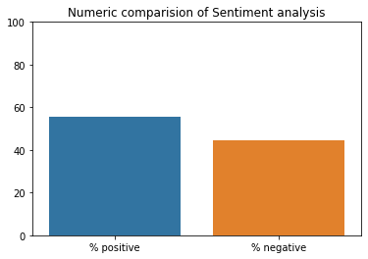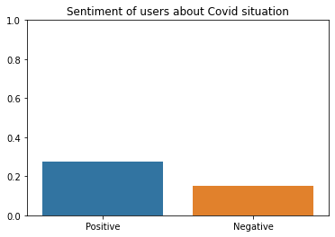Sentiment analysis:

Figure 2: This shows how many people are positive or negative about this aspect

Figure 1: This shows Intensity of negativity or positivity of sentiments

### Inference:

1. The services given by the app in covid-19 pandemic times are satisfactory

### 